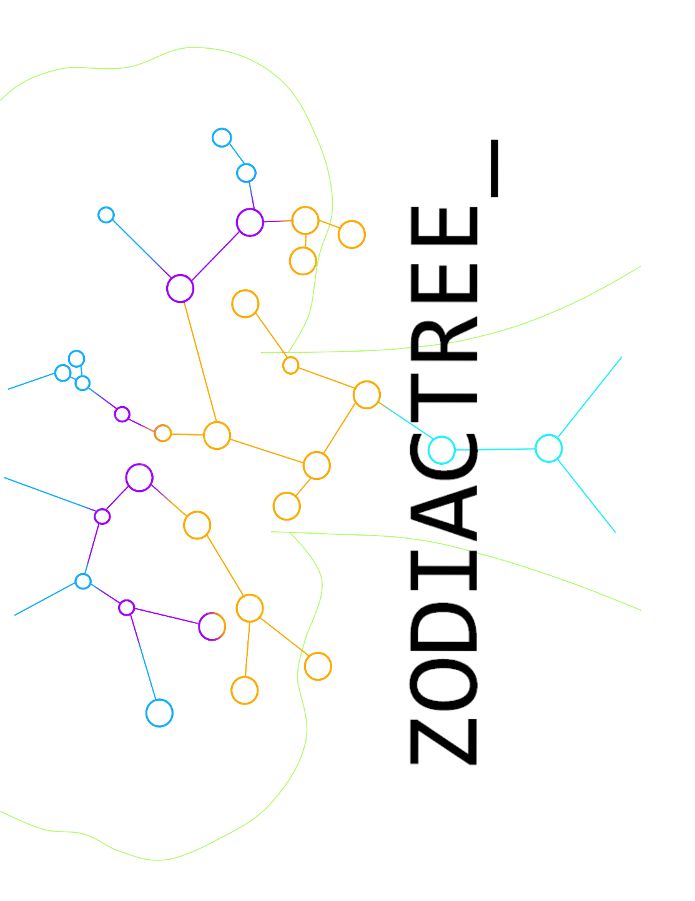

Team ZodiacTree_

Team agreements

Team members David Wan

Matthew Lau

ShiFeng Jin

Ryan Young

Junzhi ‘Jackson’ Chen

This document provides a clearer view on the guidelines that the team discussed and agreed:

1. Method of communication:

* Email
* phone calls
* SMS
* Discord (software) for voice and text chat.

1. Communication response time:

* Within 6 hours under normal condition
* ASAP for emergency.

1. Regular meeting time:

* every Wednesday 11 am – 12 pm
* one hour meeting scheduled between Saturday 7-9 pm or Sunday 7-9 pm

1. Meeting attendance:
   * All of member should be in the meeting.
   * Absence given reasonable circumstances
2. Running meeting:
   * For every Wednesday 11:30-am – 12 pm meeting:
     1. Face to face
     2. At campus location

* For every Weekend meeting:

1. Online, through Discord voice chat and text chat
2. Discussed items will be kept in the chat.
3. Meeting preparation:
   * No preparation required.
   * Issue related to the project can be raised and discussed
   * And new ideas will be examined.
4. Version control:
   * Try at our best push broken code
   * Commit message should be related to the content of the commit.
5. Division of work:
   * Most likely the coding and program designing will be split upon teams
   * Everyone is expected to do a fair share of work
6. Submitting work:
   * During the weekend meeting, members will get together and discuss the submission.
7. Contingency planning
   * TA and Prof for academic dishonesty.
   * If one of the members is dropping the course, he/she will give notice a week before
   * If he/she is sick, notify other members ASAP, so the work will be assigned to other members.